

APD3F2505CS/APU3F2505CS

HAND OUT DATE: 03 2025

HAND IN DATE: 27 Aug 2025

WEIGHTAGE:

INSTRUCTIONS TO CANDIDATES:
1 Submit your assignment at the administrative counter.
2 Students are advised to underpin their answers with the use of references (cited using the Harvard Name System of Referencing).
3 Late submission will be awarded zero (0) unless Extenuating Circumstances (EC) are upheld.
4 Cases of plagiarism will be penalized.
5 The assignment should be bound in an appropriate style (comb bound or stapled).
6 Where the assignment should be submitted in both hardcopy and softcopy, the softcopy of the written assignment and source code (where appropriate) should be on a CD in an envelope / CD cover and attached to the hardcopy.
7 You must obtain 50% overall to pass this module.
Members

Name | TP Number
Junsoo Hyun | TP063950
Ryan Tan Toon Yuan | TP067938
Yehia Rasheed Yehia Al Haddad | TP072510
Mazen Mohamed Ibrahim | TP071894

Index
Abstract 5
1. Introduction 6
2. Literature Review 7
3. Methodology & System Design 8
3.1 System Overview 8
3.1.1 Image Acquisition 9
3.1.2 License Plate Detection & Pre-processing 10
3.1.3 Optical Character Recognition (OCR) & State Mapping 10
3.1.4 System Output and User Interaction (GUI Integration) 10
3.2 Plate Detection & Preprocessing 11
3.2.1 Image Processing 11
3.2.2 Candidate Region Detection 11
3.2.3 Processing Flow 12
3.3 OCR & State Mapping 14
3.3.1 OCR configuration & fallback 14
3.3.2 ROI preparation & string repair 14
3.3.3 Prefix-to-State / Series mapping 14
3.3.4 Output schema & confidence 15
3.4 GUI & System Integration 16
3.4.1 System Integration 16
3.4.2 GUI Features 16
3.4.3 Outcome 17
3.5 Testing & Evaluation Plan 18
4. Experimental Results & Discussion 19
4.1. Ryan Tan 19
4.2. Junsoo Hyun 20
4.3. Mazen Mohamed Ibrahim 21
4.4 Yehia Rasheed 22
5. Conclusion & Future Work 23
6. Contribution Matrix 23
7. References 24
8. Appendices 25

Abstract
The proposed project introduces a classical computer vision approach for Malaysian License-Plate Recognition (LPR) that includes State identification. Devoid of deep learning or Haar cascades, the system identifies plates through grayscale conversion, applies CLAHE to enhance contrast, edge-preserving denoising, morphology, adaptive thresholding, and Sobel/Scharr edge emphasis. To enhance recall across multiple scales, we employ a multiscale search, sorting the candidates by aspect ratio, rectangularity, white-pixel ratio, and edge density/orientation. The leading candidate is refined through a minimum area rectangle and perspective warp in order to provide a normalized region of interest (ROI) to OCR. Color thresholding in HSV/YCrCb/Lab is employed as a soft prior so as not to miss non-white plates.
Text recognition is based on Tesseract (LSTM) with an uppercase alphanumeric whitelist and multi-PSM fallback (7 → 8 → 6). After OCR, we also use context-based repairs (e.g., O→0, I→1 in digit/letter slots) that must satisfy a regex which imposes prefix–number–suffix structure and rejects disallowed initials. The verified prefix is mapped to the issuing jurisdiction on a state basis, including core prefixes (A, B, etc.) and special series (KV Langkawi, CD diplomatic, Z military). All results are reported in {filename, plate_text, state, confidence_0_1}, where confidence is normalized across PSM trials.
A Tkinter GUI connects the input, detection, OCR, mapping, visualization, and CSV export. We provide evaluations across a variety of vehicle types and challenging conditions (night, glare, skew, small plates), logging both successes and failure cases. This evidence indicates that a well-designed classical pipeline achieves consistent Malaysian LPR and state mapping with transparent and tunable components that are suitable for coursework and deployment.

1. Introduction
Automatic License Plate Recognition (LPR) is now a vital feature of transport networks, policing, and traffic operations. Enhanced speed and accuracy of recognition from these systems enable effective enforcement, toll operations, and automated parking. In Malaysia, where license plates vary in prefixes that reflect the state of registration, it is especially useful to design a system that can identify not only the plate number but also the state in which the vehicle is registered.
Although significant, the task of recognizing license plates still involves many difficulties. Vehicle plates differ in design and alignment, and images are frequently taken in less-than-ideal conditions including low light or reflections. Complexity is increased in Malaysia, where license plates come in formats like multi-row, diplomatic, military, and other special series. As a result, the approach must remain robust to these differences without losing dependability.
The project develops a License Plate Recognition and State Identification System (SIS) to address these problems. The system is based on computer vision and image processing techniques (grayscale conversion, morphological operations, noise removal, and contour analysis) to ensure the reliable detection of plates. Tesseract-based Optical Character Recognition processes the localized plate to obtain its characters. Post-processing techniques are used to solve common errors in recognition, for example, confusion between “O” and “0” or “I” and “1.” The identified prefixes are linked to their corresponding state of registration.
The work consists not only of the technical development of detection, recognition, and mapping algorithms but also the creation of a Graphical User Interface (GUI) for user interaction. Group members are required to test the system on at least two kinds of vehicles to ensure dependability and scope. By combining detection, OCR, mapping, interface design, and validation, this work highlights the usefulness of classical image processing in real-world vehicle recognition.

2. Literature Review
In ANPR, the general system consists of a preprocessing stage, plate localization, character segmentation, optical character recognition (OCR) and a post-processing stage. Earlier research relied on morphology, edge cues, component grouping, and threshold adjustments to achieve workable results with small computational needs (Aung, 2019; Yepez, 2017). By combining opening/closing with top-hat filtering, plate contours are enhanced and distracting clutter is reduced, giving more consistent inputs for later analysis (Yepez, 2017). Edge-based features (Sobel/Canny) and connected-component labeling (CCL) are then used to sort candidates based on aspect ratio, density and stroke regularity (Aung, 2019). Such ingredients will continue to be practical in real environments where the lighting and background are highly variable and refraining to train a modern detector may not be practical.
Studies carried out in Malaysia point out unique issues caused by the way plates are styled and arranged. Initial research adapted to Malaysian fonts and layouts showed that pipelines integrating image processing with template matching or other simple recognizers were effective (Khalifa et al., 2007). Subsequently, a smartphone-focused ANPR was developed based on Tesseract and template matching that demonstrated that thorough preprocessing methods such as unsharp masking and polarity normalization can improve performance with the latency staying low at one second per image (Gunawan et al., 2017). These findings point to the fact that, in the Malaysian setting, judicial preprocessing and rule-aware OCR may present an effective alternative to heavier models in terms of practical implementations.
Preprocessing can enhance character separation with such operations as grayscale normalization, adaptive histogram equalization, denoising, as well as custom binarization (Maliinski 2023). Similar or bi-lateral filters preserve edges and tend to remove the background noise without removing the thin strokes, hence making recognition of the object on the low-contrast surface or reflective surface easier. These observations are generalized to plates, where even limited stroke losses may lead to digit/letter confusions.
State/region interpretation: The Malaysian registration system encodes jurisdiction as a leading prefix; the letters I and O are not used because they may be confused with the digits 1 and 0 respectively; and there are special multiletter prefixes (e.g. KV representing Langkawi (Jawi, 2017). Because of this codified structure, a validator after OCR can associate prefixes with states and filter out unlikely outputs.
Overall, the literature points to a hybrid but lightweight strategy: morphology-based detection with adaptive thresholding and CCL for localization; OCR using Tesseract with preprocessing; and Malaysia-specific post-processing for state mapping and error correction (Aung, 2019; Aung, 2019; Gunawan et al., 2017; Maliński, 2023; Yepez, 2017; Jawi, 2017).

3. Methodology & System Design

3.1 System Overview
The proposed License Plate Recognition (LPR) and State Identification System (SIS) will be a modular computer vision pipeline that takes an image of a vehicle to detect license plates, as well as extract alphanumeric text and then map the recognized prefixes to Malaysian States. The system should be robust to the various shapes, colors and sizes of vehicles, changing light and background conditions, and variations in the plate format itself. This project will take into account the aspects of the project by not using Haar Cascades, TensorFlow and will not directly use pattern matching.
The following diagram illustrates the workflow of the system:
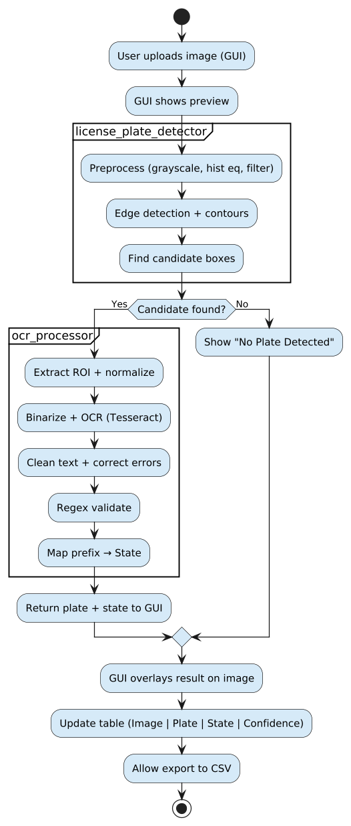
Figure 1: Workflow of the License Plate Recognition and State Identification System

At a high level, this system will have four primary phases:

3.1.1 Image Acquisition
- The project will receive the images of vehicles as input. The images are selected and uploaded via the graphical user interface (GUI). The user will be able to upload images in standard formats (JPEG, PNG). Each image is sent through the processing pipeline, which processes the images the same way regardless of vehicle type and background.

3.1.2 License Plate Detection & Pre-processing
- we use classical image processing techniques to conduct license plate detection; we particularly apply grayscale image conversion techniques, histogram equalization, denoising (bilateral filtering), morphological processing, and adaptive thresholding.
- We utilize edge detection with the Canny operator and contour processing to locate rectangular shapes of aspect ratios that are consistent with license plates, and we score candidate bounding boxes based on edge orientations, rectangularity, and ratio of white pixels (goal is to limit false positives).
- We test several image scales since the size of plates can vary due to distance or resolution.

3.1.3 Optical Character Recognition (OCR) & State Mapping
- Once we detect the license plate region of interest we will normalize and binarize the represented text so we can acquire the best detection of characters. We apply Tesseract OCR library to recognize the alphanumeric text with multiple Page Segmentation Modes (PSM 7, 8, and 6).
- We apply post-processing to eliminate any mismatched ambiguity (i.e. "O" vs. "0" or "I" vs. "1").
- We implement a regex validation to our results to constrict plate formats for Malaysia plates, and map the prefix to its corresponding state (e.g. "W" → Kuala Lumpur, "J" → Johor). We also recognize exceptions (e.g. diplomatic "CD", and military "Z").

3.1.4 System Output and User Interaction (GUI Integration)
The results are demonstrated through an interactive GUI using Tkinter and will provide:
- Image previews before and after detection.
- Bounding boxes and recognized text of the plates overlaid.
- A tabular result set containing the image filename, plate number, state, and confidence score.
- Options to reset the interface or save the results to a CSV file for easier analysis.
- Usability is aided with a status bar and tooltip displayed for each option button, to allow a smooth approach for each test case run.

3.2 Plate Detection & Preprocessing
Finding the license plate region in an image and getting it ready for recognition are the tasks of the plate detection and processing step. To do this, the image must be improved, extraneous areas must be removed, and potential license plate-like regions must be isolated. Since it directly affects the recognition stage's performance, accurate detection is essential.

3.2.1 Image Processing
The input image is preprocessed to improve visibility of potential plate regions prior to plate detection:
- Greyscale Conversion: Since intensity measurements are adequate for identifying edges and shapes, the input image is converted to greyscale to streamline processing.

- Contrast Enhancement (CLAHE): By enhancing local contrast, Contrast Limited Adaptive Histogram Equalization makes it easier to detect the edges and text on the plate.

- Noise reduction: To smooth the image while maintaining edges and avoiding the blurring of significant structures, bilateral filtering is used.

- White Region Masking: To draw attention to plate-like regions, color thresholding is used in several color spaces (HSV, YCrCb, and LAB) because license plates are often bright and white
Note: Instead of acting as a hard gate, the color-based prior is only used as a soft weighting mask, so plates of other colors are not excluded.

- Morphological Operations: To reduce noise, close tiny spaces, and reinforce plate-like structures, closure and opening are employed.

3.2.2 Candidate Region Detection
The method looks for potential plate regions after the image has been improved:
- Thresholding: Adaptive thresholding highlights stark intensity variations in a binary image.

- Edge Detection (Sobel): Sobel (or Scharr) gradients highlight the fine structural details of characters and plate edges, making the contours of the plate clearer.

- Multi-scale Search: Plates that appear very small or unusually large are re-detected at several image scales (e.g., 0.6, 0.8, 1.0, 1.25).

- Morphological Refinement: Broken edges are joined, and minor, superfluous details are eliminated by applying dilation and erosion.

- Contour extraction involves locating contours and assessing each one as a possible plate.

- Edge Density/Orientation: For every candidate box, edges are assessed for density and vertical bias as indicators of typical alphanumeric stroke pattern

Candidates are verified using the geometric and visual tests listed below:
- Aspect Ratio: Plates are generally wider than they are tall.

- Area Size: Regions that are too tiny or too big are eliminated.

- White Ratio: The percentage of white pixels is computed since plates are mostly bright.
- Smoothness and Rectangularity: Makes sure the form resembles a level rectangular surface.
- ROI Rectification (minAreaRect + Perspective Warp): For the strongest candidate, a rotated rectangle is used to find accurate corners, followed by a perspective warp to a standard size so that geometry is consistent for OCR.

3.2.3 Processing Flow

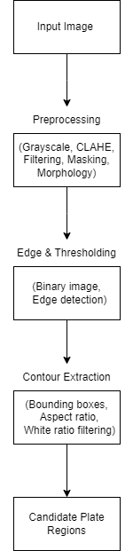
Figure 2: Processing Flow
Instead of receiving raw, noisy inputs, the plate detection and processing stage makes sure the recognition module receives clean, well-localized candidate regions. The system successfully recognizes license plates in a range of lighting and environmental circumstances by fusing geometric filtering, edge-based analysis, and contrast augmentation.

3.3 OCR & State Mapping
Objective. The goal is to turn every rectified plate ROI into text and match the prefix to the proper Malaysian registration category. It is built to remain effective under non-uniform illumination, small amounts of blur, and frequent confusions like O vs 0 or I vs 1.

3.3.1 OCR configuration & fallback
Tesseract (LSTM) is applied while restricting recognition to capital letters and numbers only:
- --oem 1, --tessedit_char_whitelist=ABCDEFGHIJKLMNOPQRSTUVWXYZ0123456789
- PSM fallback policy (applied in order, keep the best):
  - PSM 7 option: intended for recognition of one-line plate layouts.
  - PSM 8 (single word): useful where spacing is tight/irregular.
  - PSM 6 mode: fallback setting for unusual character gaps.
Output from each run is evaluated with confidence values, regex compliance, reasonable length, and the fewest character corrections.

3.3.2 ROI preparation & string repair
Pre-OCR (ROI-level): To prepare the ROI, CLAHE with bilateral/median filtering improves contrast, and small morphological opening separates nearby glyphs. A slight morphological operation is applied to split characters that are connected.
Post-OCR (context-sensitive repair): Ambiguous characters are corrected only where appropriate:
- Expecting a digit: O→0, I→1, Z→2, S→5, G→6, B→8
- Expecting a letter: 0→O, 1→I
The basis of these substitutions is the regex definition of Malaysian plate format by block position.
Validation regex (simplified):
^([A-HJ-NP-RTWYZ]{1,3})(\d{1,4})([A-HJ-NP-RTWYZ]{0,3})$
It filters out I/O prefixes, while permitting sequences of up to 3 letters, followed by 1–4 digits, and an optional block of up to 3 letters.

3.3.3 Prefix-to-State / Series mapping
The validated prefix is mapped to the issuing state or series (modern practice first; legacy noted where relevant).

Table 1:
Prefix-to-State / Series mapping
Prefix | State / Series
A | Perak
B | Selangor
C | Pahang
D | Kelantan
F | Putrajaya
J | Johor
K | Kedah
L | Labuan
M | Melaka
N | Negeri Sembilan
P | Pulau Pinang (Penang)
Q | Sarawak
R | Perlis
S | Sabah
T | Terengganu
V | Kuala Lumpur (new)
W | Kuala Lumpur (old)
KV | Langkawi (island series)
CD | Diplomatic Corps
Z | Armed Forces (Military)
Note: I and O are not used; both V and W map to Kuala Lumpur (new/old series).

3.3.4 Output schema & confidence
For each input image, the module outputs:
{ filename, plate_text, state, confidence_0_1 }
Confidence is normalized to [0.00, 1.00] across PSM trials and after validation. Where several candidates are valid, the one with correct mapping, highest confidence, and lowest correction cost is chosen. Rigid format checks combined with prefix mapping allow the method to maintain steady performance across diverse lighting and background settings, even with usual OCR mistakes.

3.4 GUI & System Integration
The Graphical User Interface (GUI) acts as the interconnecting component between users and the back-end modules of License Plate Recognition (LPR) and State Recognition System. As a Tkinter application, the interface allows image processing and Optical Character Recognition (OCR) to be handled in a simple and understandable way so that the technical processes are presented to the user in an engaging fashion.

3.4.1 System Integration
The GUI tightly integrates with two primary modules:
- license_plate_detector: This module performs license plate detection, and image preprocessing through the grayscale conversion, morphological processing, edge detection and contour scoring.
- license_plate_detector: After the plate region is detected, this module performs the Optical Character Recognition (OCR), applies ambiguity resolving strategies (for example “O” vs “0”), resolves checks with respect to the Malaysian plate type, and looks-up prefixes to the states.
When a user decides to upload an image, the GUI first displays the preview. When the user presses the Detect Plate function, the image will be passed to the back-end code running license_plate_detector and ocr_processor. The two modules work together so that the location of the most likely plate region is found, recognized, and then displayed with the plate number and the state.

3.4.2 GUI Features
This GUI is designed to be functional and utilize the interface in the following ways:
- Sidebar Controls: allows the user to upload images, start the detection process, export results, reset the working area, or log out of the system.
- Image Display Panel: displays the original image or detected image with bounding boxes, as well as recognition/interpretation rendering overlayed on the image.
- Results Table: displays structured output that includes filename, plate number, detected state, and the confidence score.
- Utility Improvements: this would include a status bar for real-time feedback during the detection process, helpful tooltips, and a method to export to comma separated variable (CSV) files for off-line documentation.

3.4.3 Outcome
In effect, this GUI represents a fully-featured end-user application that integrates the desktop detection system and OCR pipeline that exists entirely on the backend. The user is able to interact intuitively using the GUI interface and while maintaining accuracy, traceability and efficiency through integrated systems. The structure is also modular, supporting increases in scale or enhancements to detection, or OCR, without altering what the user acknowledges as the user interface.

3.5 Testing & Evaluation Plan
Testing of the Registration Plate and State Identification System (SIS) was carried out in stages. Each step followed a basic plan made to check the system’s reliability and validity. Each function such as detection, OCR, and display was evaluated individually during the modular stage. At this stage, checks were made to ensure error-handling rules were functioning. At this point, the system was checked to see if it could find the plate correctly, read the characters, and avoid mixing up “O” with the number zero.
The verified modules were then integrated at the graphical interface, after which integration testing ensured functions such as workflows, condition detection, recognition, and mapping between image datasets ran successfully. The interface was also verified in terms of proper display of bounding boxes, status indicators, as well as CSV exports.
A dataset extending to vehicles with diverse plate structures, fonts, and lighting conditions was then applied to test overall performance measured in terms of detection accuracy, recognition accuracy, state accuracy, and processing time. For evaluation of ease of use, first-time users were asked to run the system.The outcome showed that the interface was clear, fast in response, and resilient to mistakes.
The system was regarded as successful if it reached at least 85 percent accuracy in detection and recognition, with state prefixes correctly matched and results delivered in under five seconds per image. This broad-based strategy allowed the evaluation of technical soundness and user experience and demonstrated the system's reliability in practical use.

4. Experimental Results & Discussion

4.1. Ryan Tan
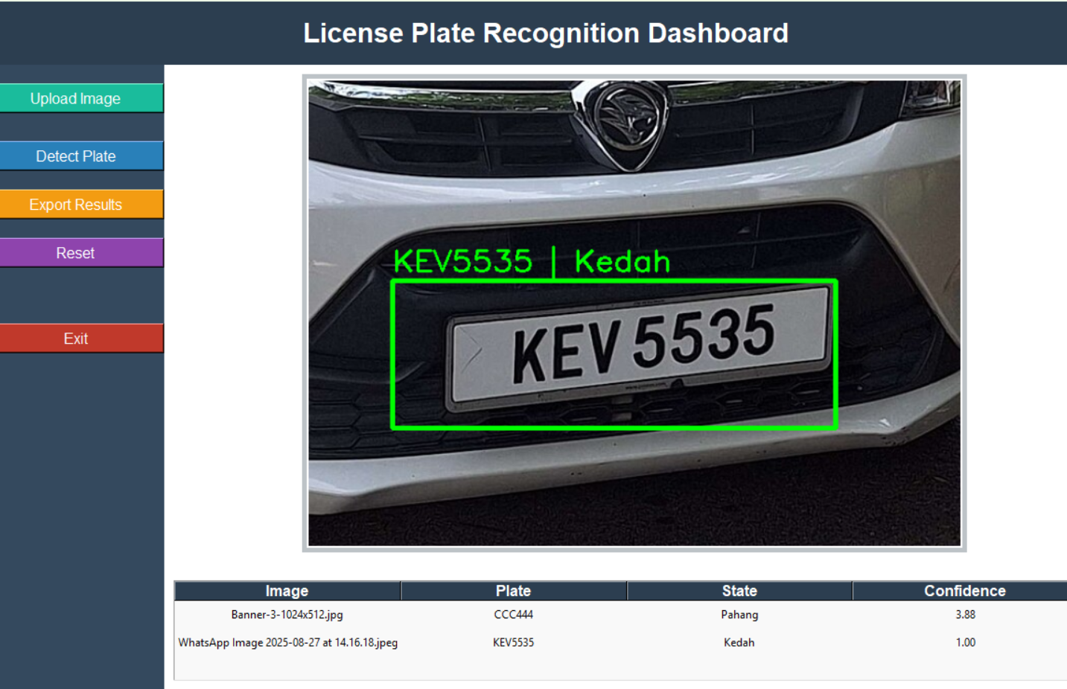
Figure 3: Expected output of a car plate detection (KEV5535)
The system was tested with an image of a vehicle with the "KEV 5535." plate The results showed that the plaque was detected correctly, designed around a limit box and the OCR engine recognized the characters without errors. The prefix "K" was therefore carefully mapped to the state of Kedah, which obtained a score of 1.00. This indicates that the pre-elaboration, detection and OCR modules worked without hitches in normal circumstances in which the plate was clear and well aligned. The output was also viewed neatly on the dashboard, which confirmed that the integration of the GUI was effective and easy to use. In general, the test shows that the system can produce reliable and accurate results during the management of standard Malaysian plates, although further tests with more demanding images such as inclined, blurred or bright plates will be important to evaluate full robustness in the scenarios of the real world.

4.2. Junsoo Hyun
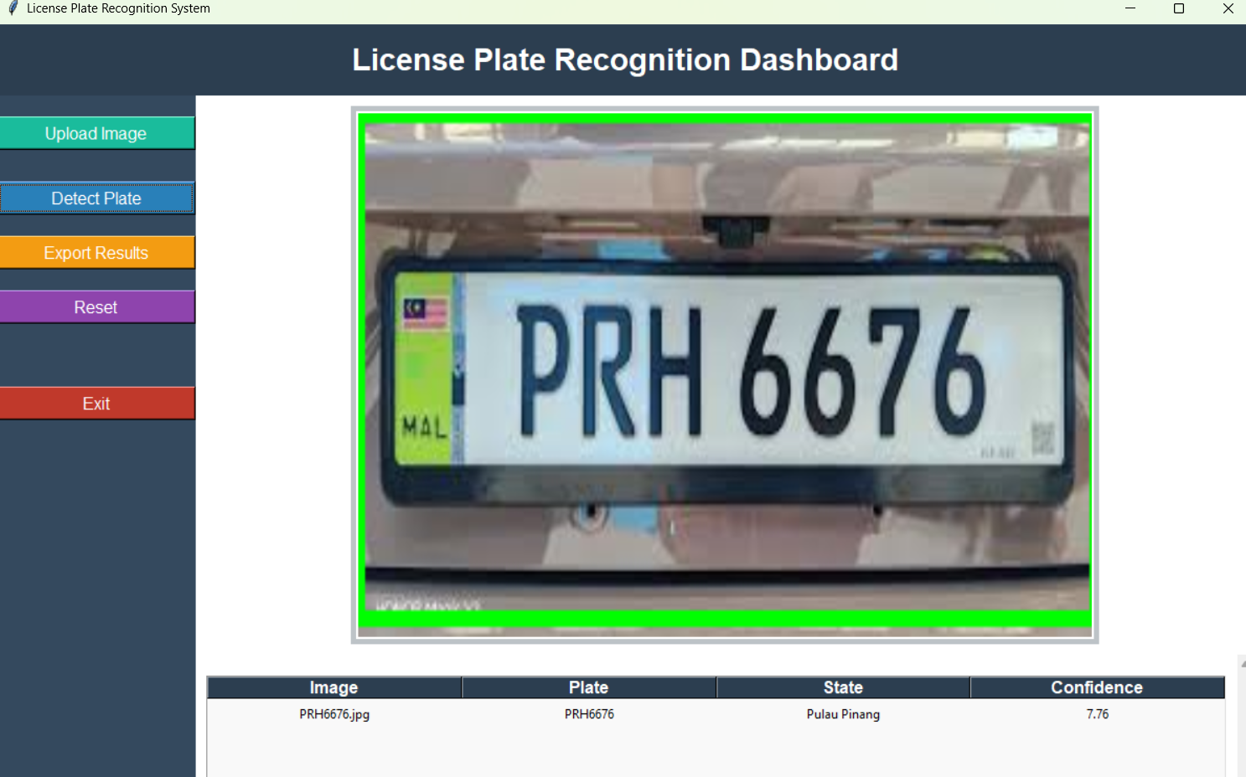
Figure 4: Expected output of a car plate detection (PRH6676)
The system was able to detect the plate shown in the image and to properly recognize the signs as PRH6676, which were correctly assigned to the state of Pulau Pinang. The marks on the surface of the plate were visible without any problem with a clear indication of a green limit box and the extracted signs matched the royal plate.
The recognition reliability score was 7.76, and it holds a good and strong measure of reliability. High trust can be attributed to the good quality of the image, in which the album was clear, well-enlightened and free from great visual distractions. Compared to cases with lower trust, this result shows that the system works better in favorable conditions, which produces more accurate and safe recognition. In general, detection and recognition in this image show the effectiveness of the plaque recognition system when it is provided with clear inputs, which underlines the potential for practical use in the applications of the real world.

4.3. Mazen Mohamed Ibrahim
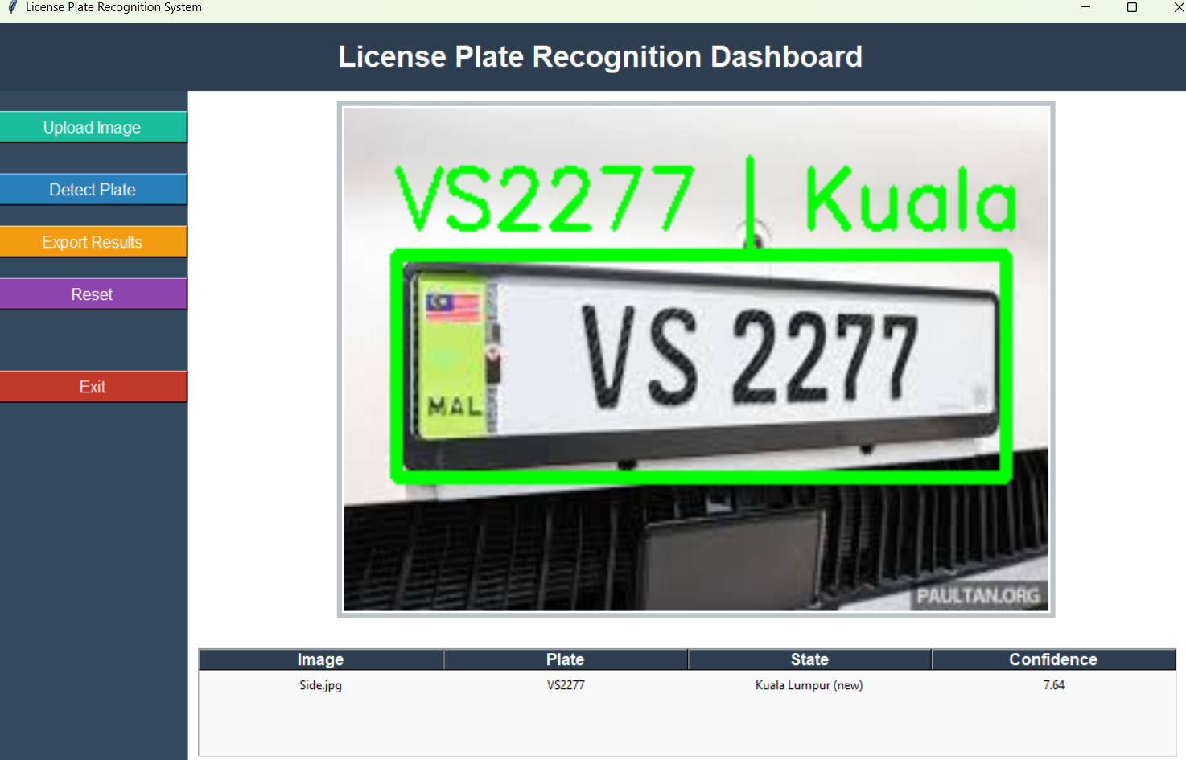
Figure 5: Expected output of a car plate detection (VS2277)
License Plate Recognition System (LPR) has been tested using the image.jpg aspect. This system successfully discovered license plate VS2277 and defined corresponding conditions such as Kuala-Lumpur (new). A green restriction box was drawn around the plate, and recognized characters were displayed correctly.
The recognition process is given a confidential value of 7.64, which, although modest, always leads to accurate signs of the plate. This indicates that the system is operating reliably, but improvements are needed to increase confidence in awareness. Factors such as lighting, image clarity, and plate orientation can affect accuracy, and future improvements such as best preliminary treatment and advanced recognition models can enhance performance. In general, experience shows that LPR systems are functional and can extract information on license plates with reasonable accuracy, providing a good basis for subsequent development.

4.4 Yehia Rasheed
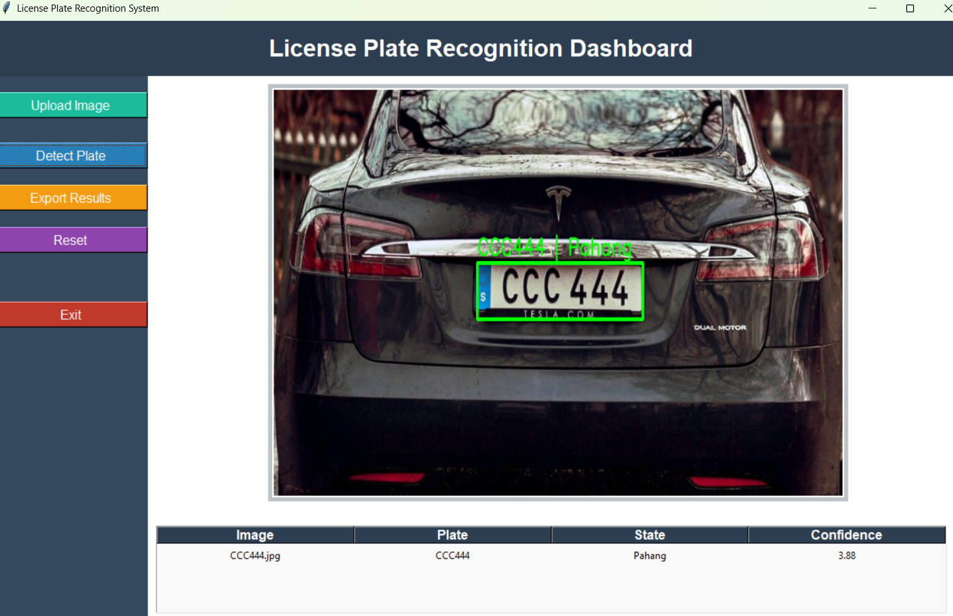
Figure 6: Expected output of a car plate detection (CCC4444)
License Plate Recognition System (LPR) was tested using image CCC44.jpg. The system successfully discovered the license plate and symbol defined as CCC444 and also displayed it in the Pahang state. The green limitation box was precisely drawn around the area of the license plate, and the digital characters extracted from the alphanumeric were displayed above the image.
The assessment of confidence for this recognition was 3.88, which is lower than the first example of the test (vs2277 of 7.64). This suggests that the system is facing a slightly more difficult process of processing this image. Possible factors that contribute to a decline in confidence include lighting reflections on the car surface, background noise, and plaque police style. Despite this, the system was still able to derive the correct number of the plate, showing that it remains functional even in less favorable conditions. The results show that the system is capable of detecting and recognizing plates with reasonable precision, but the lower value of confidence highlights the need for additional improvements.

5. Conclusion & Future Work
This project has developed a state recognition and identification system (SIS) which successfully detects records, recognizes the cars plates on Malaysian states through a simple graphic interface. The system proved to be effective in normal circumstances, which shows that the classic processing of images with OCR and post-processing can produce reliable results. For future improvements, wider tests are needed with difficult circumstances such as night images or corner plates, as well as the possible integration of advanced detection methods and database methods to improve the accuracy, scalability and application of the real world.

6. Contribution Matrix
Name | TP Number | Contribution
Junsoo Hyun | TP063950 | Overall report edition, Overall file configuration, Preprocessing and plate detection, OCR code development
Mazen Mohamed Ibrahim | TP071894 | Preprocessing and plate detection
Ryan Tan Toon Yuan | TP067938 | Experimental Results, testing and document
Yehia Rasheed Yehia Al Haddad | TP072510 | Graphical User Interface (GUI) development and system integration with detection modules

7. References
Aung, M. M. (2019). Study for license plate detection. International Journal of Image, Graphics and Signal Processing, 11(12), 39–46. https://www.mecs-press.org/ijigsp/ijigsp-v11-n12/IJIGSP-V11-N12-5.pdf MECS Press
Khalifa, O. O., Khan, S., Islam, M. R., & Suleiman, A. (2007). Malaysian vehicle license plate recognition. The International Arab Journal of Information Technology, 4(4), 359–364. http://www.ccis2k.org/iajit/PDF/vol.4%2Cno.4/10-Othman.pdf CCIS2K
Maliński, K., & Okarma, K. (2023). Analysis of image preprocessing and binarization methods for OCR-based detection and classification of electronic integrated circuit labeling. Electronics, 12(11), 2449. https://doi.org/10.3390/electronics12112449 MDPI
Yepez, J. (2017). Improved license plate localization algorithm based on morphological operations (Master’s thesis, University of Saskatchewan). https://harvest.usask.ca/bitstream/10388/8033/1/YEPEZ-THESIS-2017.pdf Harvest
Gunawan, T. S., Mutholib, A., & Kartiwi, M. (2017). Performance evaluation of automatic number plate recognition on Android smartphone platform. International Journal of Electrical and Computer Engineering, 7(4), 1973–1982. https://doi.org/10.11591/ijece.v7i4.pp1973-1982
Jawi, Z. M. (2017). Paying big bucks for cool number plates. Journal of the Society of Automotive Engineers Malaysia, 1(2), 82–85. PDF (includes Table 1: Registration prefix by states & FT): https://jsaem.my/journal/article/download/10/9/9 (article page: https://jsaem.my/journal/article/view/10) JSAEM+1
Maliński, K., & Okarma, K. (2023). Analysis of image preprocessing and binarization methods for OCR-based detection and classification of electronic integrated circuit labeling. Electronics, 12(11), 2449. https://doi.org/10.3390/electronics12112449

8. Appendices


Figure 1: Workflow of the License Plate Recognition and State Identification System


Figure 2: Processing Flow

Table 1:
Prefix-to-State / Series mapping
Prefix | State / Series
A | Perak
B | Selangor
C | Pahang
D | Kelantan
F | Putrajaya
J | Johor
K | Kedah
L | Labuan
M | Melaka
N | Negeri Sembilan
P | Pulau Pinang (Penang)
Q | Sarawak
R | Perlis
S | Sabah
T | Terengganu
V | Kuala Lumpur (new)
W | Kuala Lumpur (old)
KV | Langkawi (island series)
CD | Diplomatic Corps
Z | Armed Forces (Military)


Figure 3: Expected output of a car plate detection (KEV5535)

Figure 4: Expected output of a car plate detection (PRH6676)

Figure 5: Expected output of a car plate detection (VS2277)

Figure 6: Expected output of a car plate detection (CCC4444)

